Project 2 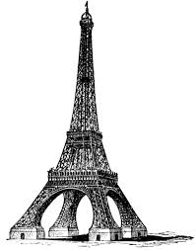
Course: MAT-110

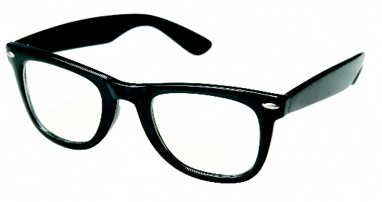
Name
_________________________
Due Date
January 15, 2015
Instructor: Dr. Valluru

- PHOTOCHROMATIC EYEGLASS LENSES Photo chromatic eyeglass lenses contain molecules of silver chloride or silver halide. These molecules are transparent in the absence of UV rays. UV rays are normally absent in artificial lighting. However, when the lenses are exposed to UV rays, as in direct sunlight, the molecules take on a new molecular structure, which causes the lenses to darken. The number of molecules affected varies with the intensity of the UV rays. The intensity of UV rays is measured using a scale called the UV index. On this scale, a value near 0 indicates a low UV intensity and a value near 10 indicates a high UV intensity.
For the photo chromatic lenses shown below, the function models the transparency P of the lenses as a function of the UV index x.
UV index, 0
Lens transparency, 100%
UV index, 5
Lens transparency, 65.91%

UV index, 9
Lens transparency, 47.22%

- Find the transparency of these lenses, to the nearest tenth of a percent, when they are exposed to light rays with UV indices of 3.5, 6.3, 8.275, and 7.05.
- What are the UV indices of light rays that cause these photo chromatic lenses to have transparencies of 45%, 38.92%, 0.7684, and 23.4%? Round to the nearest tenth.

- EIFFEL TOWER The functions
h₁(x)

and
h₂(x)
approximate the height, in meters, of the Eiffel Tower x meters to the right of the center line, shown by the y-axis in the following figure.
The graph of h models the shape of the tower from ground level up to the second stage in figure, and the graph of g models the shape of the tower from the second stage up to the third stage.
Determine the horizontal distance across the Eiffel Tower, rounded to the nearest tenth of a meter, at a height of
- 78 meters
- 36.9 meters
- 200.2 meters
Determine the height of the tower at a horizontal distance of
- 15.6 meters
- 52.12 meters

- MODELING DATA In a study relating sleep and death rate, the following data were obtained. Use the function to model the data.
x  (Average Number of Hours of Sleep) | y  (Death Rate per Year per 100,000 Males)
4 | 1735
7 | 655
9 | 988

According to this model, find out death rate per year per 100,000 males when average number of sleeping hours is 8.

- SOLVING SYSTEM OF NON-LINEAR INEQUALITIES Graph the solution set of the following systems:

- On your next vacation, you will divide lodging between large resorts and small inns. Let x represent the number of nights spent in large resorts. Let y represent the number of nights spent in small inns.

- Write a system of inequalities that models the following conditions:

You want to stay atleast 5 nights. At least one night should be spent at a large resort. Large resorts average $200 per night and small inns average $100 per night. You budget permits no more than $700 per lodging.

- Graph the solution set of the system of system of inequalities in part (A).
- Based on your graph in part (B), what is the greatest number of nights you could spend at a large resort and still stay within your budget?

- CRYPTOGRAPHY Explain how you use matrix operations in cryptography. Justify your answer with examples.

