Frequency distribution: Worksheet: Date: September 12, 2014
1. Arrange the following data in ascending order.
(a) 7, 2, 10, 14, 0, 6, 15, 24, 8, 3
(b) 4.6, 8.1, 2.0, 3.5, 0.7, 9.3, 1.4, 0.8
2. Arrange the following data in descending order.
(a) 14, 2, 0, 10, 6, 1, 22, 13, 28, 4, 8, 16
(b) 1.2, 3.5, 0.1, 0.3, 2.4, 8.6, 5.0, 3.7, 0.7, 0.9
3. Construct the frequency table for each of the following.
(a) 4, 3, 6, 5, 2, 4, 3, 3, 6, 4, 2, 3, 2, 2, 3, 3, 4, 5, 6, 4, 2, 3, 4
(b) 6, 7, 5, 4, 5, 6, 6, 8, 7, 9, 6, 5, 6, 7, 7, 8, 9, 4, 6, 7, 6, 5
4. The marks obtained out of 25 by 30 students of a class in the examination are given below.
20, 6, 23, 19, 9, 14, 15, 3, 1, 12, 10, 20, 13, 3, 17, 10, 11, 6, 21, 9, 6, 10, 9, 4, 5, 1, 5, 11, 7, 24
Represent the above data as a grouped data taking the class interval such as 1 - 5
5. Complete the table given below.
(a)
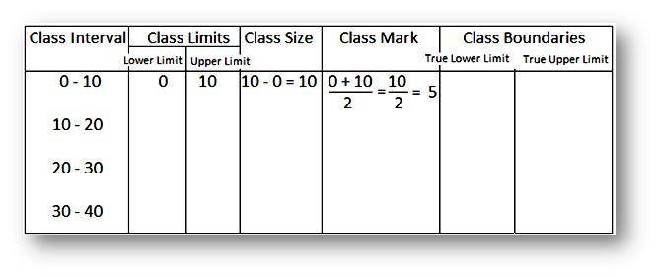
(b)
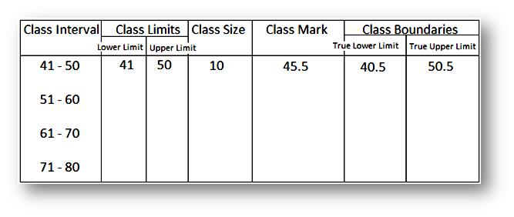
6. Weekly pocket expenses (in $) of 30 students of class VIII are 37, 41, 39, 34, 71, 26, 56, 61, 58, 79, 83, 72, 64, 39, 75, 39, 37, 59, 57, 37, 53, 38, 49, 45, 70, 82, 44, 37, 79, 76. Construct the grouped frequency table using 6 classes.
7. Pulse rate (per minute) of a group of people in a neighborhood were recorded as
61, 75, 71, 72, 70, 65, 77, 72, 67, 80, 77, 62, 71, 74, 79, 67, 80, 77, 62, 71, 74, 61, 70, 80, 72, 59, 78, 71, 72, 58, 54, 90, 54, 90, 56, 68, 53, 69, 55, 79, 67, 55, 78, 61, 72, 69, 50, 89, 83, 57, 75. Construct a frequency table using 8 classes.
8. The frequency distribution of weights (in kg) of 40 persons is given below.
Weights (in kg) | 30 - 35 | 35 - 40 | 40 - 45 | 45 - 50 | 50 - 55
Frequency | 6 | 13 | 14 | 4 | 3
(a) What is the lower limit of fourth class interval?
(b) What is the class size of each class interval?
(c ) Which class interval has the highest frequency?
(d) Find the mid-points of all the class intervals?
9. Construct the frequency distribution table for the data on heights (cm) of 40 boys using the 7 class intervals. The heights of the boys in cm are: 140, 138, 133, 148, 160, 153, 131, 146, 134, 136, 149, 141, 155, 149, 165, 142, 144, 147, 138, 139, 174, 167, 128, 176, 177, 168, 135, 153, 142, 159, 129, 138, 147, 169, 154, 183, 166, 170, 155, and 180. Also, find the range of heights of the boys.
10. Construct a frequency distribution table for the following weights (in gm) of 30 oranges using the five class intervals. The weights are: 31, 41, 46, 33, 44, 51, 56, 63, 71, 71, 62, 63, 54, 53, 51, 43, 36, 38, 54, 56, 66, 71, 74, 75, 46, 47, 59, 60, 61, 63. (a) What is the class mark of the class intervals 50-55? (b) What is the range of the above weights? (c) How many class intervals are there? (d) Which class interval has the lowest frequency?

